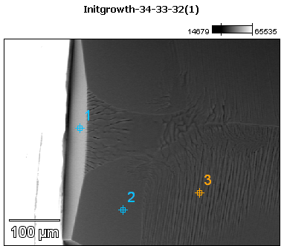

Image Name: Initgrowth-34-33-32(1)

Image Resolution: 512 by 384

Image Pixel Size: 1.08 µm

Acc. Voltage: 12.0 kV

Magnification: 230

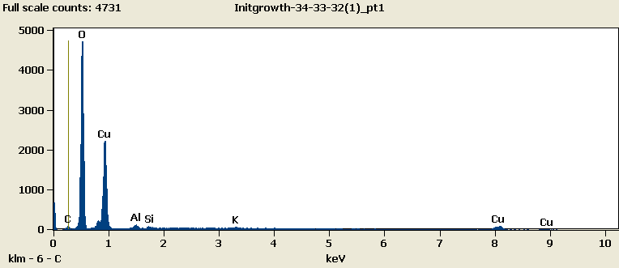

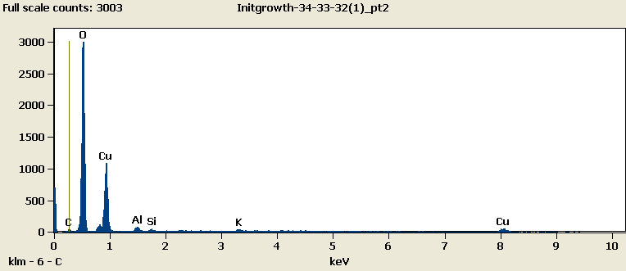

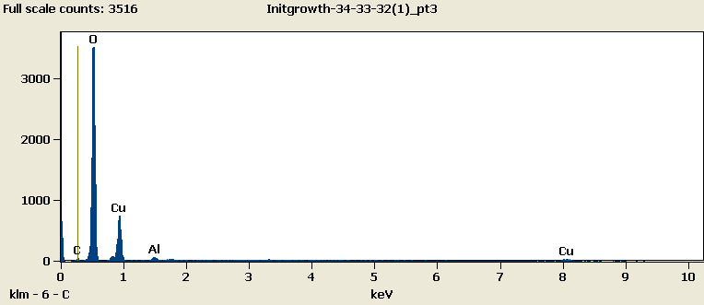

Weight %

|  |  |  |  |  |  |  |
| --- | --- | --- | --- | --- | --- | --- |
|  | ***C-K*** | ***O-K*** | ***Al-K*** | ***Si-K*** | ***K-K*** | ***Cu-L*** |
| ***Initgrowth-34-33-32(1)_pt1*** | 2.23 | 44.85 | 1.02 | 0.61 | 0.57 | 50.72 |
| ***Initgrowth-34-33-32(1)_pt2*** | 1.96 | 51.34 | 1.26 | 0.68 | 1.03 | 43.74 |
| ***Initgrowth-34-33-32(1)_pt3*** | 1.37 | 60.36 | 1.09 |  |  | 37.18 |

Weight % Error (+/- 1 Sigma)

|  |  |  |  |  |  |  |
| --- | --- | --- | --- | --- | --- | --- |
|  | ***C-K*** | ***O-K*** | ***Al-K*** | ***Si-K*** | ***K-K*** | ***Cu-L*** |
| ***Initgrowth-34-33-32(1)_pt1*** | ±0.18 | ±0.28 | ±0.06 | ±0.06 | ±0.09 | ±0.47 |
| ***Initgrowth-34-33-32(1)_pt2*** | ±0.23 | ±0.36 | ±0.13 | ±0.08 | ±0.13 | ±0.60 |
| ***Initgrowth-34-33-32(1)_pt3*** | ±0.23 | ±0.38 | ±0.13 |  |  | ±0.60 |

# Cations

|  |  |  |  |  |  |  |
| --- | --- | --- | --- | --- | --- | --- |
|  | ***C-K*** | ***O-K*** | ***Al-K*** | ***Si-K*** | ***K-K*** | ***Cu-L*** |
| ***Initgrowth-34-33-32(1)_pt1*** | 0.00 | 0.00 | 0.00 | 0.00 | 0.00 | 0.00 |
| ***Initgrowth-34-33-32(1)_pt2*** | 0.00 | 0.00 | 0.00 | 0.00 | 0.00 | 0.00 |
| ***Initgrowth-34-33-32(1)_pt3*** | 0.00 | 0.00 | 0.00 |  |  | 0.00 |